WEEK 4

Supervised Learning Model Implementation

Objective:
The objective is to design and implement supervised learning Mode for Regression using python on a publicly available dataset and build predictive model

Dataset Used For Regression:
California Housing dataset
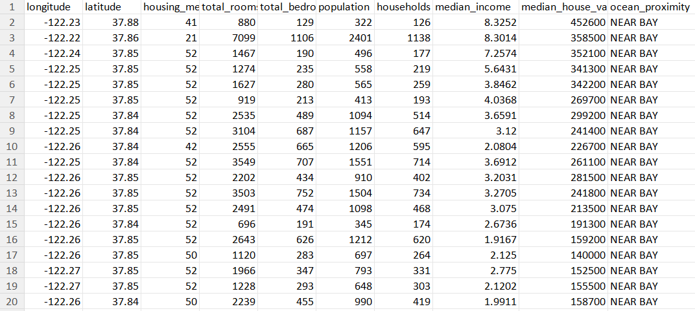
The California Housing dataset is a historical dataset used to predict the median price of homes in various neighborhoods across California based on local economic and demographic data. It has 20640 rows and there are 10 attributes: longitude , latitude , housing_median_age , total_rooms , total_bedrooms , population , households , median_income , median_house_value , and ocean_proximity .
Importing Libraries:
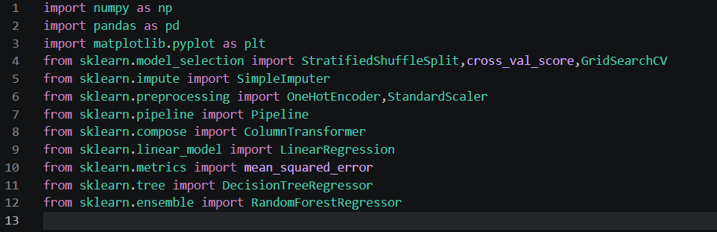
We are using pandas for data manipulation, numpy for mathematical operations and matplot for plotting graphs and relations. Others will be explained as we proceed further

Loading, understanding and visualizing data
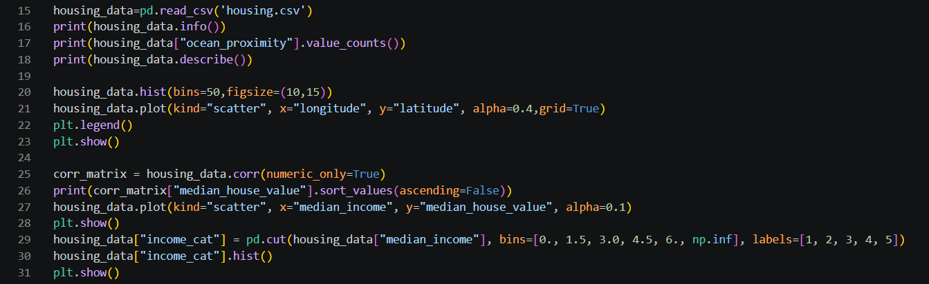
- From the info function we can see that we have 9 numerical attributes and 1 categorical(ocean proximity). And total bedrooms have some missing values
- Describe is used to analyze each numerical attribute in detail, like the mean, std deviation, min and max values.
- Also ocean_proximity has 5 different values: <1H OCEAN ,INLAND ,NEAR OCEAN ,NEAR BAY ,ISLAND
- We plot the histogram to see how often numerical data falls within specific ranges
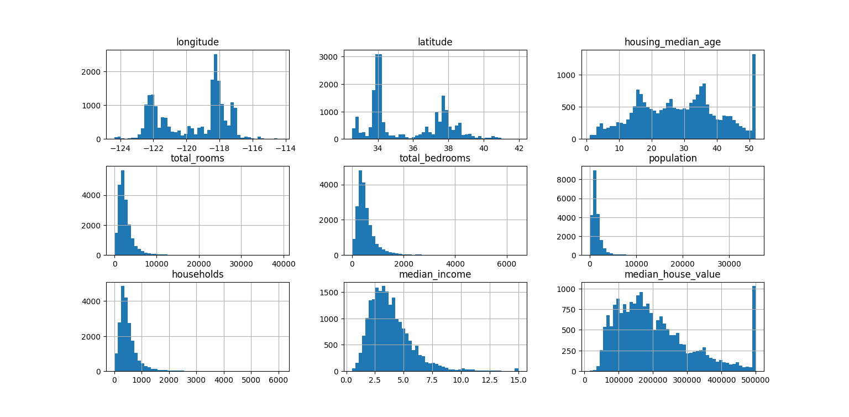
- To visualize the location of houses we plot the scatter plot of longitude vs latitude
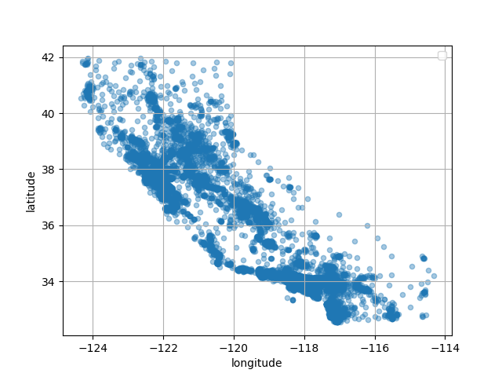
- The corr function gives the correlation coefficient ranging from –1 to 1. When it is close to 1, it means that there is a strong positive correlation, close to –1 means that there is a strong negative correlation, close to 0 mean that there is no linear correlation
- We get this correlation coefficients for median_house_value
median_house_value | 1.000000
median_income | 0.688075
total_rooms | 0.134153
housing_median_age | 0.105623
households | 0.065843
total_bedrooms | 0.049686
population | -0.024650
longitude | -0.045967
latitude | -0.144160

- Median income vs median house value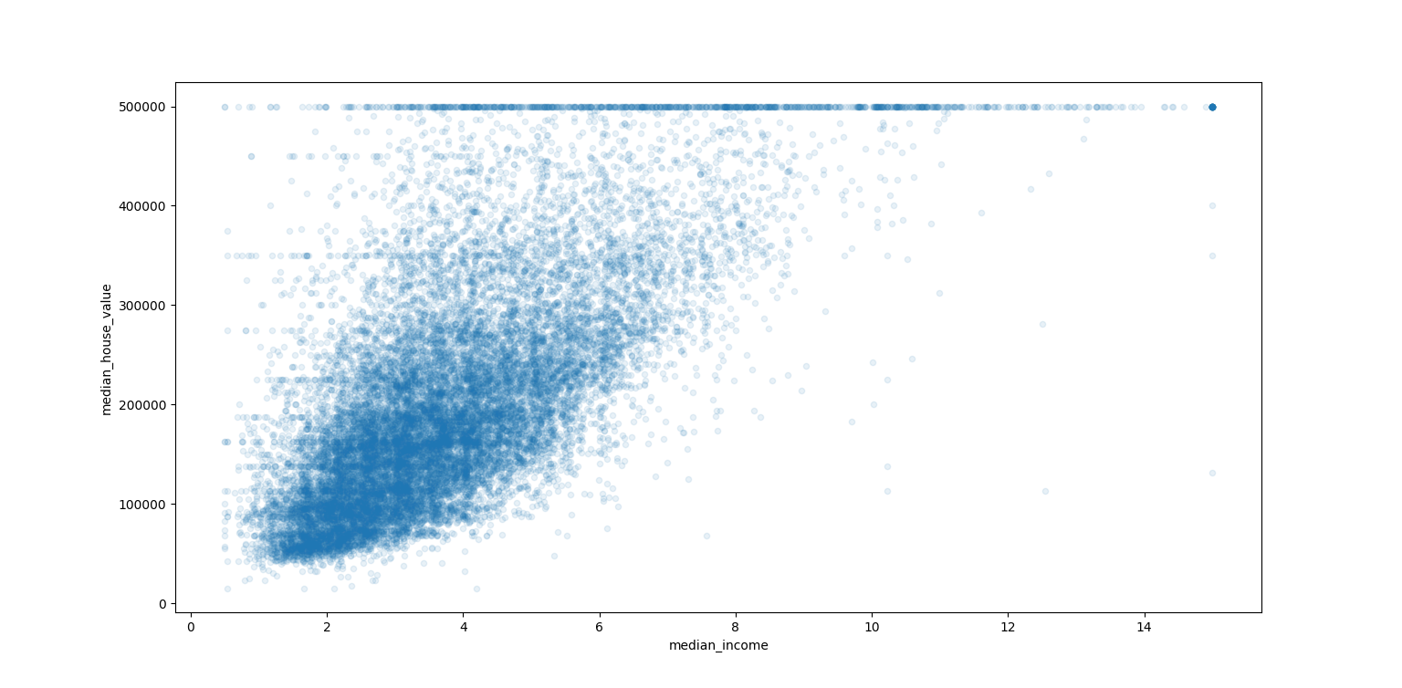
- This plot reveals that the correlation is indeed very strong; you can clearly see the upward trend, and the points are not too dispersed. Second, the is clearly visible as a horizontal line at $500,000
- pd.cut() function to create an income category attribute with five categories (labeled from 1 to 5)
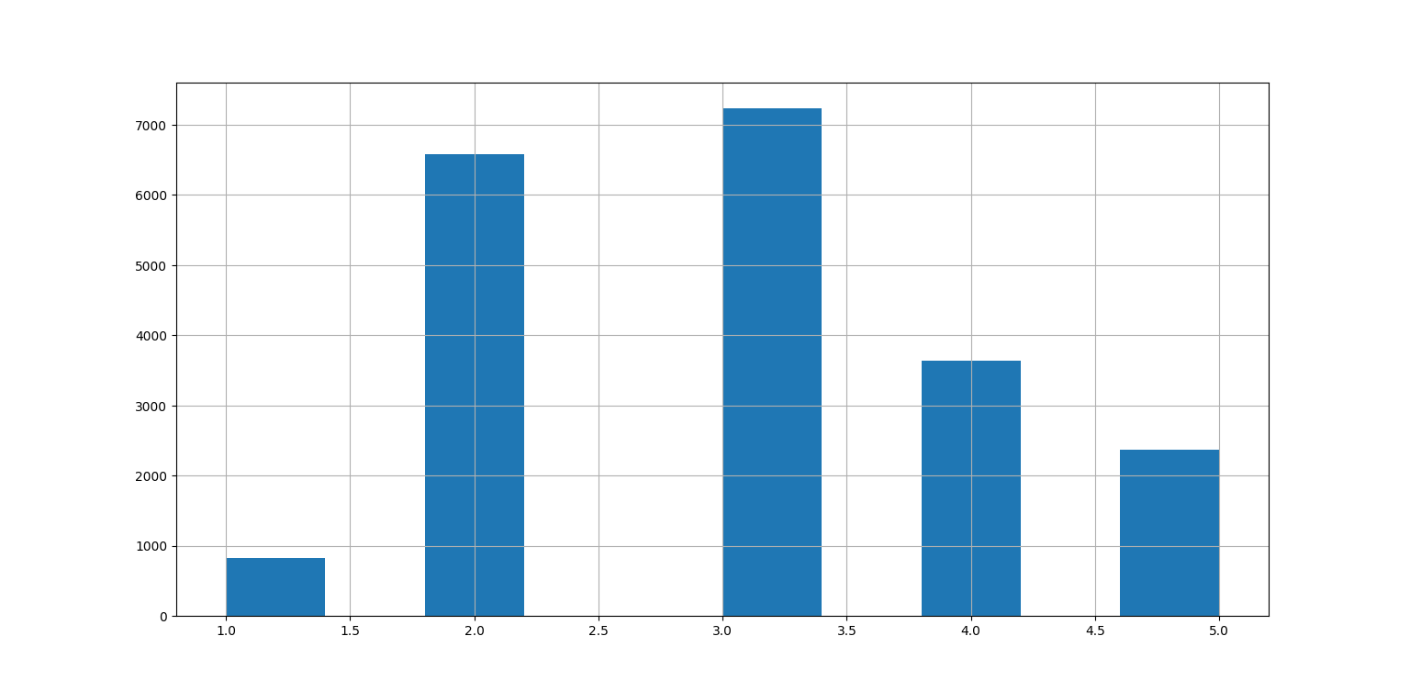
Adding some useful features and splitting the data:
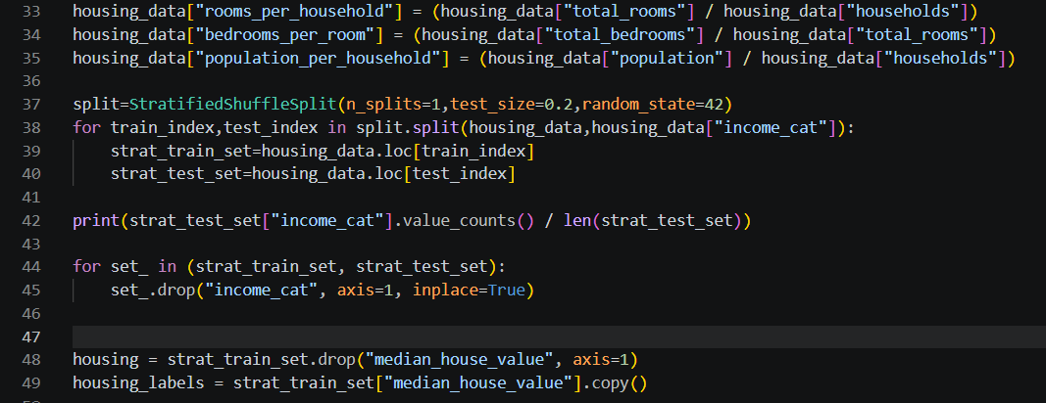
- We are adding rooms per household,bedrooms per house and population per household. These will help the model learn better
- We will then split the data into training and test set(having size 20% of the total data) using the stratifiedshufflesplit class doing this ensures that data is divided into homogeneous subgroups and guarantee that the test set is representative of the overall population
- We also drop the income_cat attribute which we created as it is no use for our training and testing. We also separate the label median_housing_value from the data which we have to predict

Cleaning data and handling categorical data:
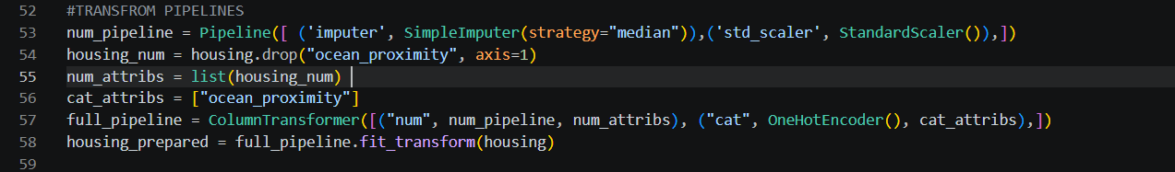
- As we have seen earlier total bedrooms have some missing values and ML algorithms cannot work with missing and categorical data.
- To handle numerical data we will replace the missing values with their median using the simple imputer and also we have to scale the features so that large scale features don't dominate the model training . we do this using the standardscaler function and we make a pipeline so that every time we dont have to do this manually
- To handle categorical data we will be changing them to some numeric quantity .OneHotEncoder class to convert categorical values into one hot vectors .One-hot encoding treats all categories as equal and independent which is the case for our regression task.
- We then combine the two pipelines using columnTransformer
Choosing Model:
1:Linear Regression
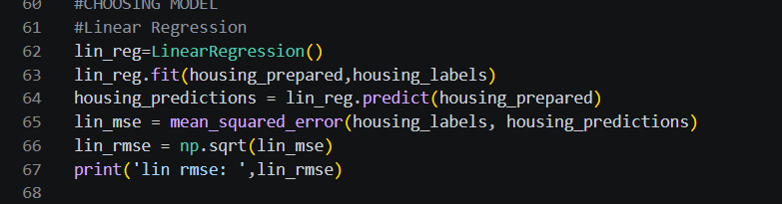
- First we will be looking at linear regression.It assumes a direct, straight-line relationship between the variables .It uses the least squares method to minimize the total squared distance (residuals) between actual data points and the predicted line.
- To train a model we first have to create a object of its class.then we can fit the training data into the model on which the model will learn. The task of a model is try to minimize the cost function.Linear regression draws a straight line which will best fit the training data
- After training we can get the mean_squared_error on the training data by comparing the actual house_price vs the predicted value: and then we can take square root of that to get the root_mean_squared_error which in our case is: 68160.92435491859
2: Decision Tree
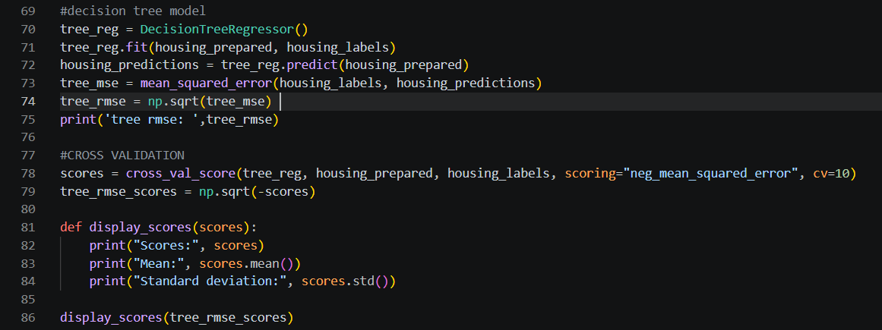
- A decision tree is a flowchart-like model which splits data and make predictions based on a series of yes-or-no questions
- After fitting the data and calculating root_mean_squared_error(rmse), we get it as 0
- This could be because the model is overfitting( i.e model learns the training data too well, memorizing noise and random fluctuations rather than actual pattern), therefore i has high chance it will perform poorly on the test set
- Therefore we will be using the cross validation to check if it is actually overfitting or not.K-fold cross-validation randomly splits the training set into 10 distinct subsets called folds, then it trains and evaluates the Decision Tree model 10 times, picking a different fold for evaluation every time and training on the other 9 folds
- We get the following result:
- Scores: [71432.07736411, 70191.0479548,1 67769.10060116, 71601.44287292
68714.40638601, 77137.63468377, 70378.62031626, 72191.78073695
68389.28660887, 70294.27839074]
- Mean: 70809.96759156033
- Standard deviation: 2515.85442084364
- It shows that the decision tree is even worse than the linear regression so we cannot use it

3: Random Forest Regression
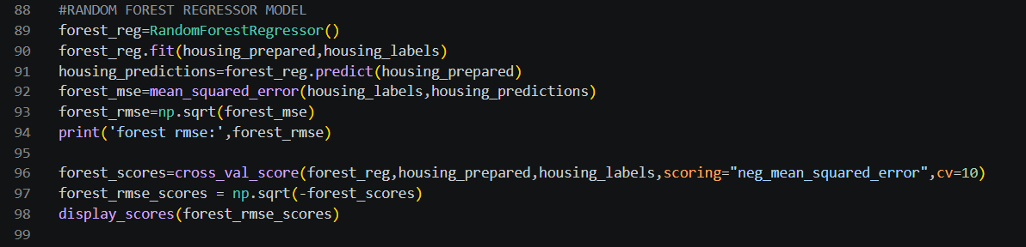
- Random Forest Regression is a powerful ensemble learning method used to predict continuous numerical values . Instead of relying on a single, complex model, it combines the predictions of multiple decision trees to produce a more accurate and stable final output
- After that we fit the training data and also perform cross validation on random_forest.
- We get the results as:
- forest rmse: 18750.42935634674
- Scores: [51432.82475186, 48958.27519591, 46673.96556351, 52001.11009011
47431.84633785 ,51578.62094649, 52520.23651564, 49537.29804834
48955.54692311, 54158.12624954]
- Mean: 50324.78506223739
- Standard deviation: 2262.394954219936
- We can see that this model perform better than the other two, so now we can use it on the test set.

Fine Tuning The Model:
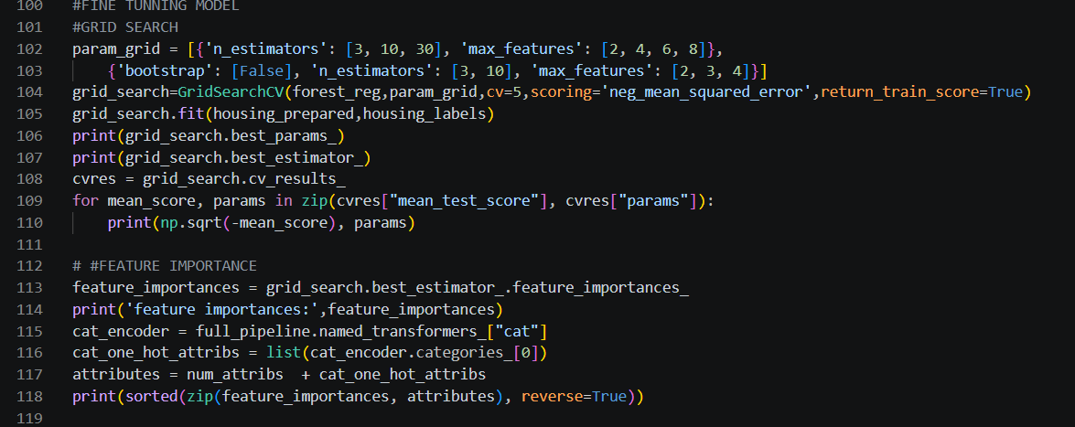
- Before testing random_forest on the test set we have to fine tune its hyperparameters( i.e we will search for the best hyperparameters ).Right now we are using the default values which the scikit_learn class provides. But doing so manually will would be very tedious work
- So we will be using Scikit-Learn’s GridSearchCV .you need to tell it which hyperparameters you want it to experiment with and what values to try out, and it will use cross-validation to evaluate all the possible combinations of hyperparameter values
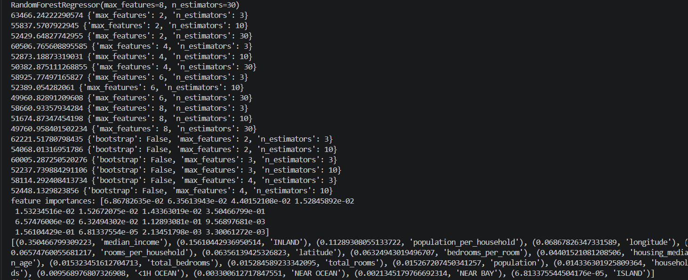
- Feature importance gives indicates the relative importance of each attribute for making accurate predictions . You can see from the output the feature importance paired with its attribute

Testing Our final Model:
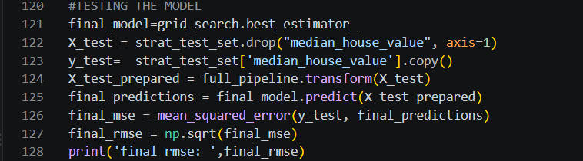
- We can get the best estimator through the grid_search.best_estimator_ attribute
- We then drop the median_house_value(label) from our test set and pass the test data through the pipeline which we created earlier which will scale and encode our data.
- After that we use the predict method on our final model to get the predictions.
- Then we calculate MSE and RMSE which come to be: 48075.87105162535.
- That concludes our house_prediction regression task

Conclusion:
The California Housing Price Prediction task successfully demonstrated the complete implementation of a supervised learning regression workflow using Python and Scikit-learn. The dataset was analyzed through exploratory data analysis, correlation analysis, and visualization to understand the relationships between housing attributes and median house value. Feature engineering was performed by creating useful attributes such as rooms per household, bedrooms per room, and population per household. Stratified sampling based on income categories was used to create representative training and testing datasets.
Three regression models—Linear Regression, Decision Tree Regression, and Random Forest Regression—were implemented and evaluated. Cross-validation was used to obtain a more reliable estimate of model performance, while GridSearchCV was applied to tune the Random Forest hyperparameters. The comparison showed that the Random Forest model generally provides better predictive performance than the simpler Linear Regression and Decision Tree models because it can capture complex and nonlinear relationships between housing features.
Finally, the optimized Random Forest model was evaluated on the unseen test dataset using Root Mean Squared Error (RMSE). Feature importance analysis also helped identify which housing attributes contributed most to price prediction. Overall, this task provided practical understanding of data preprocessing, feature engineering, model selection, cross-validation, hyperparameter tuning, and final model evaluation. The model can be further improved by experimenting with additional regression algorithms, more advanced feature engineering, hyperparameter optimization, and larger or more recent housing datasets.

